Meeting Summary:

Team Members:
-James Phillip De Guzman
-Nefi Zaldana
-Jeremy Aaron Herrera

Project name: MedRef – Medical Reference API for ICD Codes
Purpose: A working medical reference system that retrieves ICD-10 data and presents it cleanly to users
Name of repository: medref
Description: Medical reference API for ICD code lookup using MedlinePlus Connect
Problem: ICD codes are hard to interpret
Solution: simple lookup tool
Architecture: Blazor WASM → ASP.NET API → MedlinePlus Connect

GitHub Repo URL Link:
https://github.com/jamesphillipdeguzman/medref

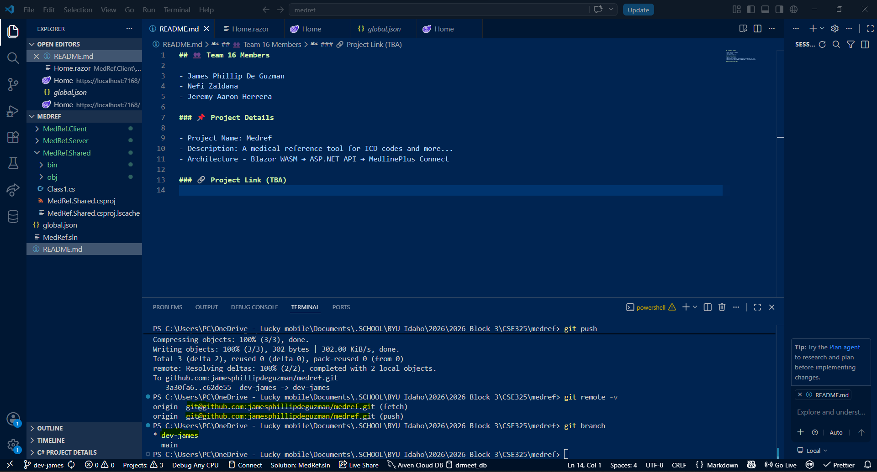
Local Clone Screenshot:

List of Proposals:
1. Medical Reference Tool
- Features: ICD code search, medical information lookup, patient case management
- Target Audience: Medical students, healthcare workers, and learners
2. Expenses/Budget Tracker App
- Features: Expense tracking, budget monitoring, transaction management
- Target Audience: Students, families, and personal finance users

